**Homework 9**

**01286121 Computer Programming**

**Software Engineering Program,**

**Department of Computer Engineering,**

**School of Engineering, KMITL**

By

65011693 Soe Moe Htet

No.1

Code

from tkinter import *

from tkinter import messagebox

Expression = ""

class mobile_phone:

    def __init__(self, window):

        self.number = StringVar()

        window.title("KMITL Phone")

        self.text = Entry(window, textvariable = self.number, justify="right")

        self.text.grid(row = 1, columnspan=4, ipadx=80, sticky= "W")

        self.button1 = Button(window, width = 12, text = "1", command=lambda:self.ph_no("1"))

        self.button1.grid(row=2, column= 0)

        self.button2 = Button(window, width = 12, text = "2",  command=lambda:self.ph_no("2"))

        self.button2.grid(row=2, column= 1)

        self.button3 = Button(window, width = 12,text = "3", command=lambda:self.ph_no("3"))

        self.button3.grid(row=2, column= 2, sticky= "W")

        self.button4 = Button(window, width = 12,text = "4", command=lambda:self.ph_no("4"))

        self.button4.grid(row=3,  column= 0)

        self.button5 = Button(window, width = 12,text = "5", command=lambda:self.ph_no("5"))

        self.button5.grid(row=3, column= 1,)

        self.button6 = Button(window, width = 12,text = "6", command=lambda:self.ph_no("6"))

        self.button6.grid(row=3, column= 2,sticky= "W")

        self.button7 = Button(window, width = 12,text = "7", command=lambda:self.ph_no("7"))

        self.button7.grid(row=4, column= 0, )

        self.button8 = Button(window, width = 12,text = "8", command=lambda:self.ph_no("8"))

        self.button8.grid(row=4, column= 1, )

        self.button9 = Button(window, width = 12,text = "9", command=lambda:self.ph_no("9"))

        self.button9.grid(row=4, column=2, sticky= "W")

        self.button10 = Button(window, width = 12,text = "*", command=lambda:self.ph_no("*"))

        self.button10.grid(row=5, column= 0, )

        self.button0 = Button(window, width = 12,text = "0", command=lambda:self.ph_no("0"))

        self.button0.grid(row=5, column= 1, )

        self.button11 = Button(window, width = 12,text = "#", command=lambda:self.ph_no("#"))

        self.button11.grid(row=5, column=2, sticky= "E")

        self.talkbutton = Button(window, width = 20, text = "Talk", command=self.Talk)

        self.talkbutton.grid(row=6 , column= 0, columnspan = 2, sticky= "W")

        self.deletebutton = Button(window, width = 20, text = "<", command=self.delete)

        self.deletebutton.grid(row=6 ,column= 1, columnspan = 2, sticky= "E")

    def ph_no(self, ph_no):

        global Expression

        Expression = Expression + str(ph_no)

        self.number.set(Expression)

    def Talk (self):

        messagebox.showinfo("Dial", f"Dialing <<{self.text.get()}>>")

    def delete(self):

        global Expression

        Expression = Expression[0: len(Expression) - 1]

        self.number.set(Expression)

def main():

    window = Tk()

    m = mobile_phone(window)

    window.mainloop()

main()

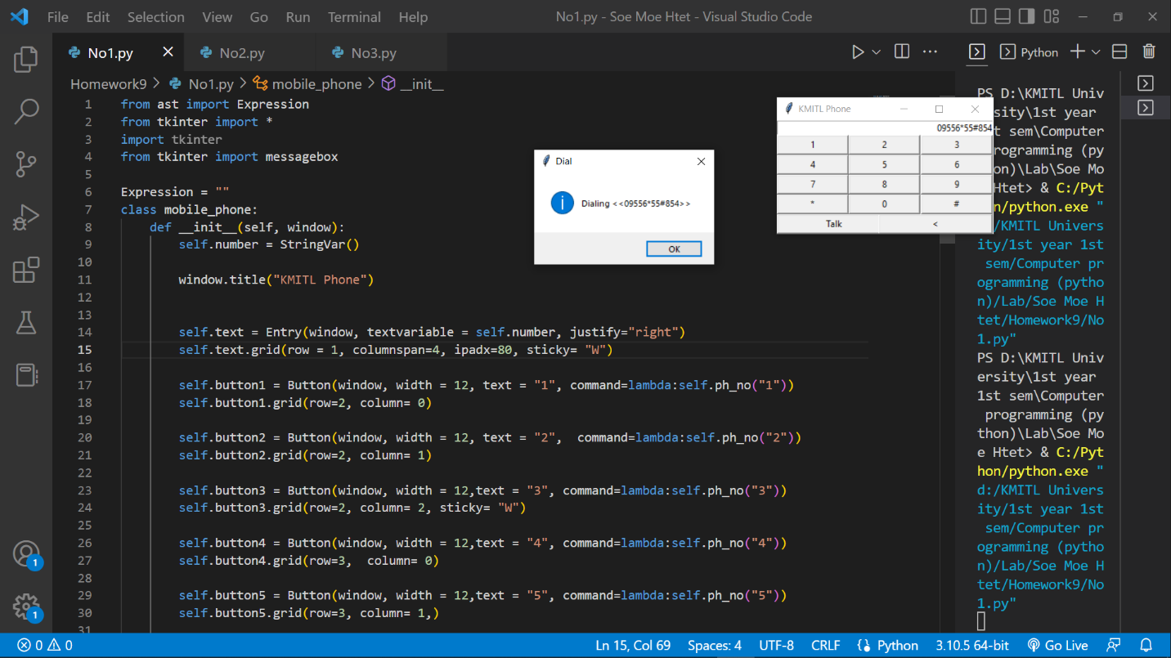

No.2

Code

from tkinter import *

from tkinter import messagebox

class circle:

    def __init__(self, window):

        self.window = window

        self.canvas = Canvas(

            window,

            width = 700,

            height = 700,

            bg = "light blue"

            )

        self.title = Label(window, width = 8, height= 1, text = "Translator application", font = "Bold 30", bg = "blue", fg='#ffffff')

        self.title.place(x = 580, y = 0, width = 400, height = 60)

        # menubar = Menu(window)

        # filemenu = Menu(menubar, tearoff=0)

        # filemenu.add_command(label="New",           command = self.donothing)

        # filemenu.add_command(label="Open",          command = self.donothing)

        # filemenu.add_command(label="Save",          command = self.donothing)

        # filemenu.add_command(label="Save as...",    command = self.donothing)

        # filemenu.add_command(label="Close",         command = self.donothing)

      # filemenu.add_separator()

      # filemenu.add_command(label="Exit", command=window.quit)

      # menubar.add_cascade(label="File", menu=filemenu)

        # menubar.place(x = 300, y = 0)

        varList = StringVar(window)

        varList.set("Thai")

        om = OptionMenu(window, varList, "Japanese", "English", "Burmese")

        om.config(width=10)

        om.config(height=2)

        om.config(font= "2")

        om.config(bg='orange')

        om.pack()

        om.place( x = 500, y = 300)

        self.number = StringVar()

        self.text = Entry(window, font = "Bold 20", textvariable = self.number, justify="right")

        self.text.place(x = 500, y = 400, width = 200, height = 40)

        self.result = "<Translated text>"

        self.output = Label(window, font = "Bold 15", text = self.result, justify="right")

        self.output.place(x = 850, y = 400, width = 200, height = 40)

        varList = StringVar(window)

        varList.set("English")

        om = OptionMenu(window, varList, "Japanese", "Thai", "Burmese")

        om.config(width=10)

        om.config(height=2)

        om.config(font= "2")

        om.config(bg='orange')

        om.pack()

        om.place( x = 850, y = 300)

        self.menu = Button(window, text = "Translate", width = 10, height= 1, font = "bold 20", fg = "white", bg = "brown", command = self.donothing)

        self.menu.pack(pady=20)

        self.menu.place(x = 700, y = 600)

        self.canvas.pack()

        window.mainloop()

    def donothing(self):

        messagebox.showinfo("Do nothing", "You pressed 'Translate' button but there is no function about it yet.")

def main():

    window = Tk()

    c = circle(window)

main()

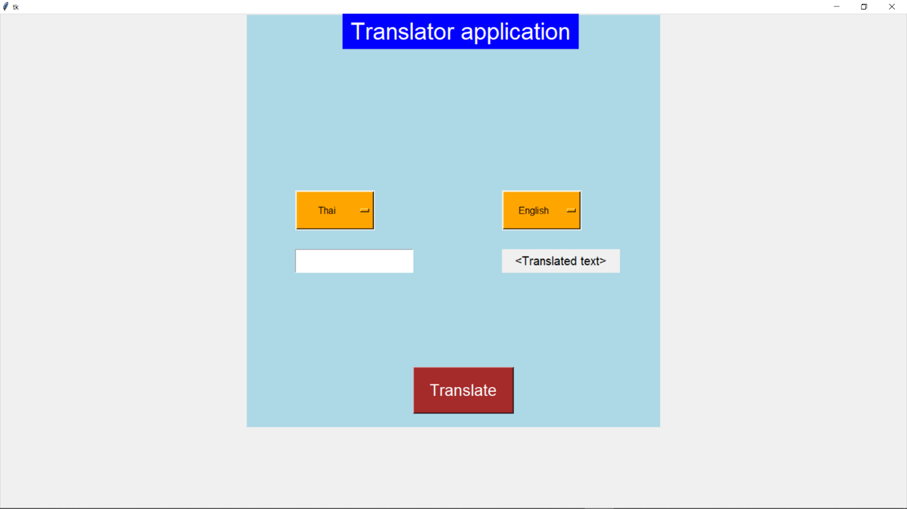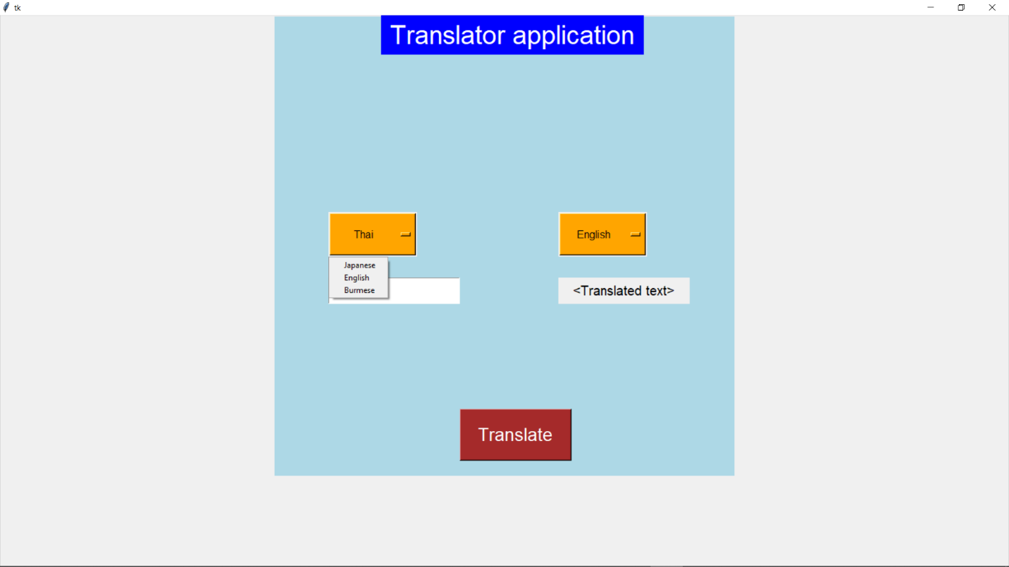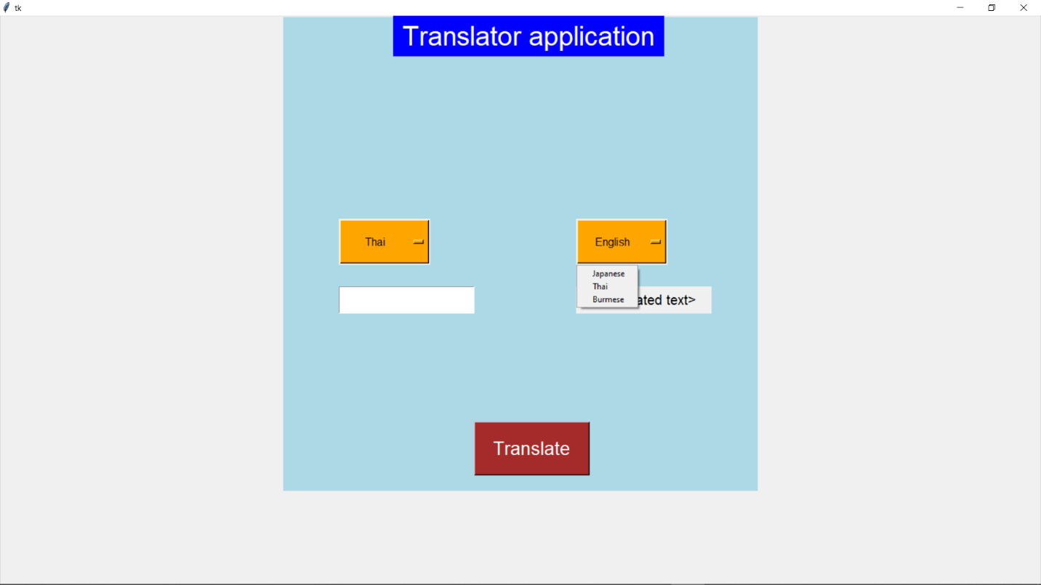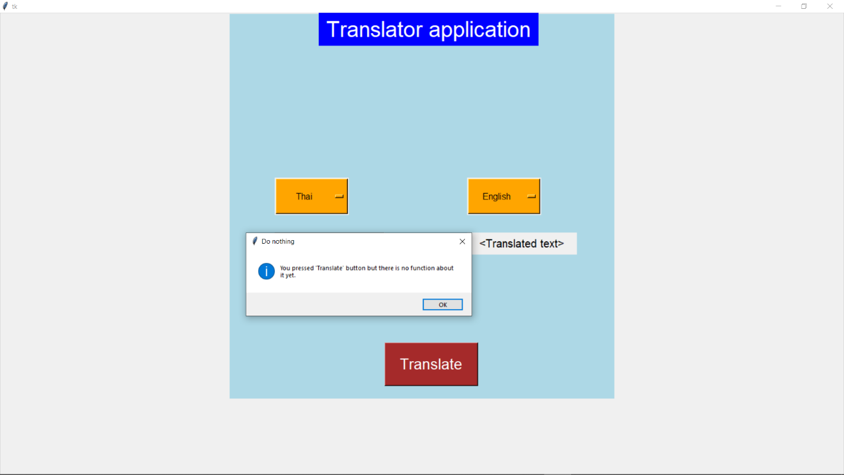

No.3

Code

from tkinter import *

class circle:

    def __init__(self, window):

        self.canvas = Canvas(

            window,

            width = 500,

            height = 200,

            bg = "white"

            )

        self.canvas.bind("<Button- 1>", self.draw)

        self.canvas.bind("<Button- 3>", self.remove)

        self.canvas.pack()

        window.mainloop()

    def draw(self, event):

        self.x1 = event.x

        self.y1 = event.y

        self.x2 = event.x + 35

        self.y2 = event.y + 35

        self.oval = self.canvas.create_oval(self.x1, self.y1, self.x2, self.y2)

    def remove(self, event):

        tag = self.canvas.find_closest(event.x, event.y)

        self.canvas.delete(tag)

def main():

    window = Tk()

    c = circle(window)

main()

